# Pick up Your Chart – Bibliography

*For many years, people have tried to classify all the existing visualising methods in insightful sections. Let’s have a look of what they have done so far. Reverse chronological order.*

## The graphic continuum

Author: John Swabish and Severinno Ribecca

Link: [PolicyViz.com](https://policyviz.com/2014/09/09/graphic-continuum/)

Description: It’s my view of the many different types of visualizations available to us when we encode and present data.

Note: Kantar IIB award winner

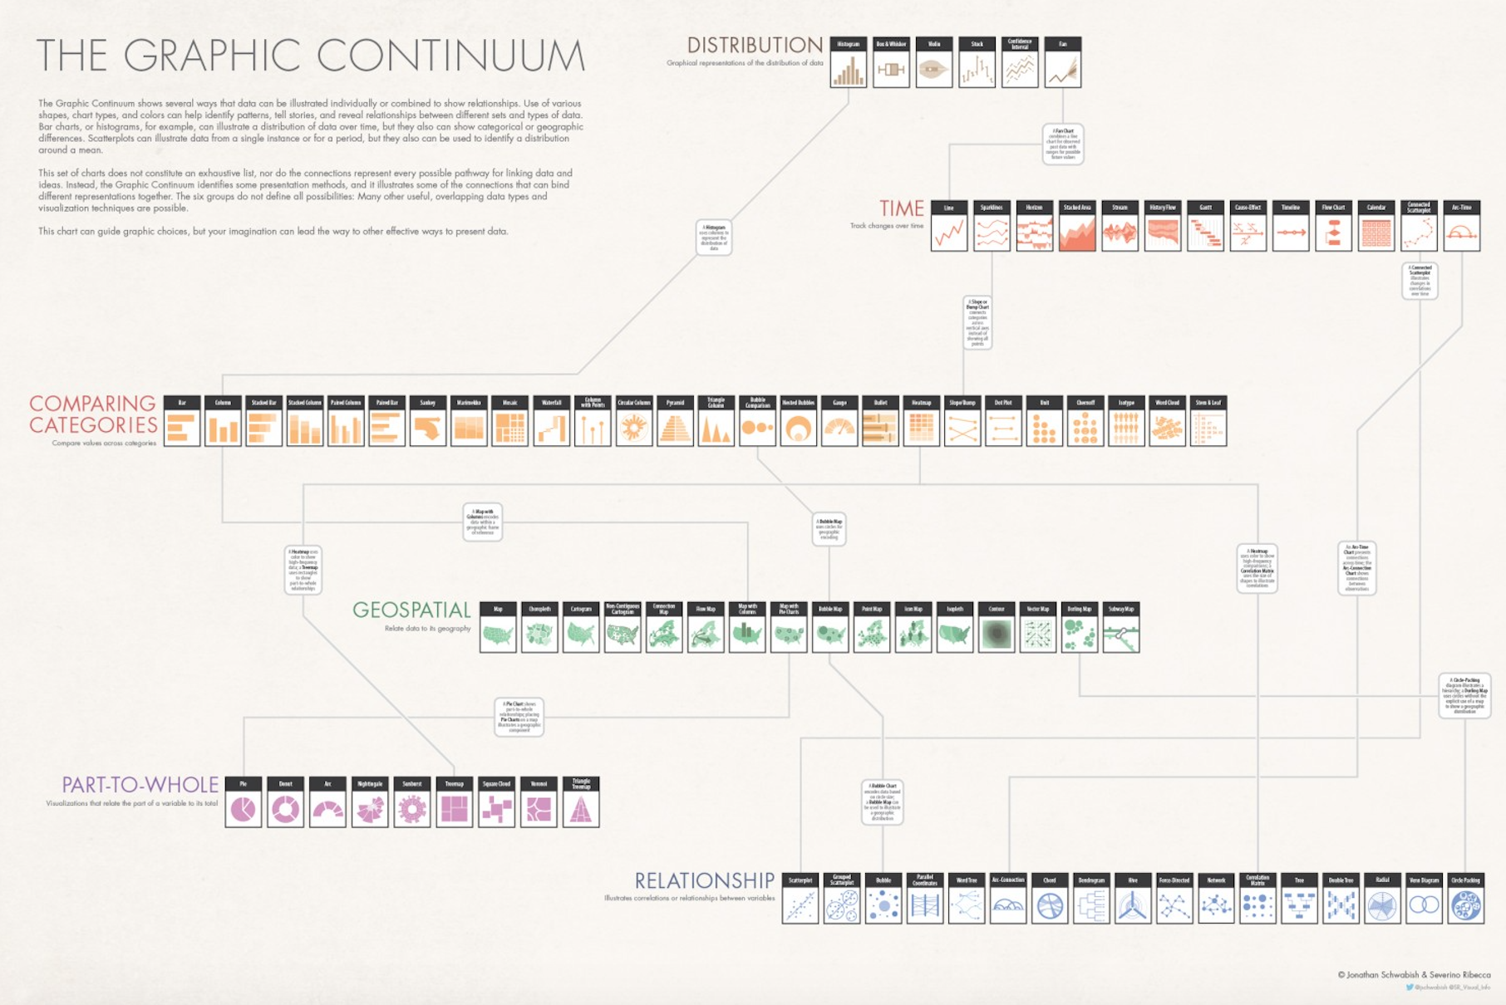

## The Visual Vocabulary

Author : Made by the financial time.

Link : ft.com/vocabulary

Description : A poster and [web site](http://ft-interactive.github.io/visual-vocabulary/) to assist designers and journalists to select the optimal symbology for data visualisations, by the [Financial Times Visual Journalism Team](https://www.ft.com/visual-journalism). Inspired by the [Graphic Continuum](https://policyviz.com/2014/09/09/graphic-continuum/) by Jon Schwabish and Severino Ribecca.

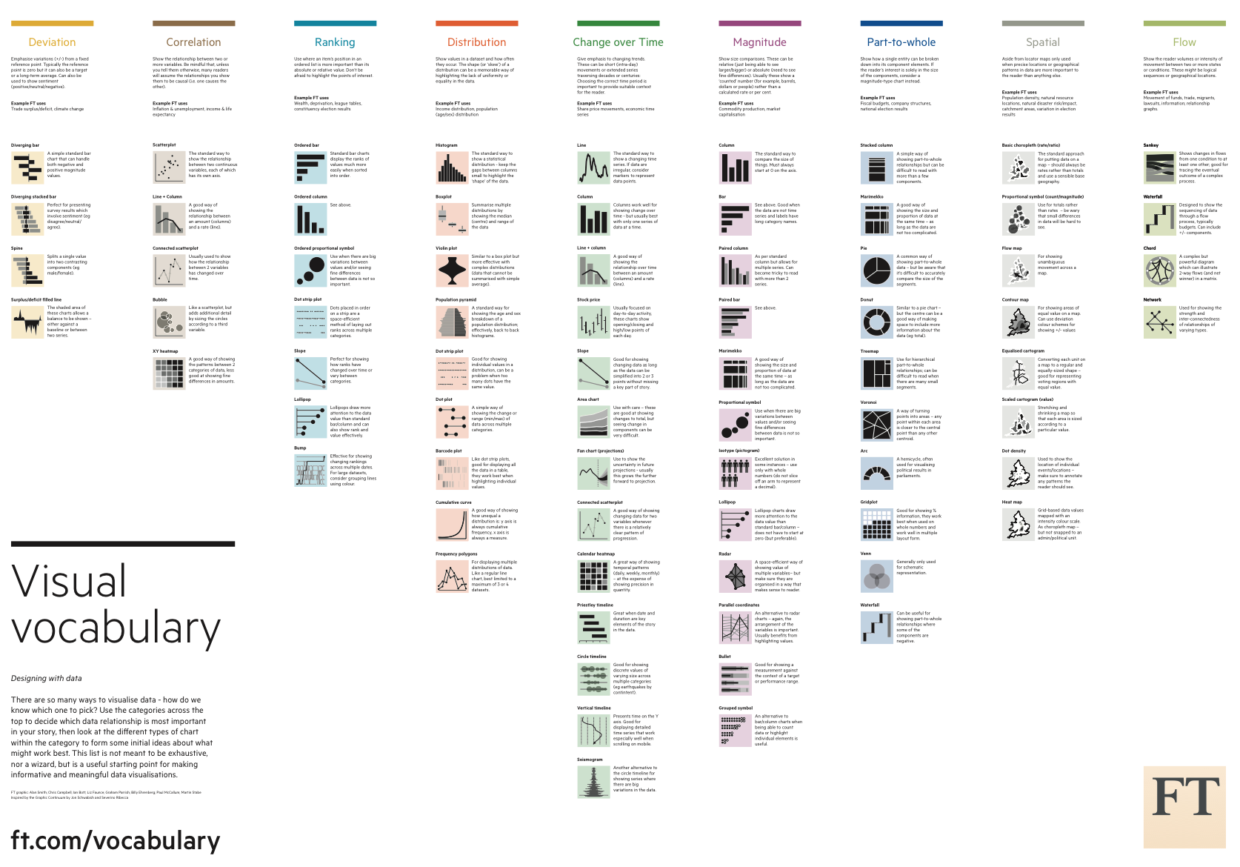

## The chart chooser:

Author: [Andrew Abela](http://extremepresentation.typepad.com/) ?

Date : September 06, 2006

Link: The [extreme presentation method](http://extremepresentation.typepad.com/blog/2006/09/choosing_a_good.html).

Description: The chart chooser is [step 7](http://www.extremepresentation.com/design/charts/) in the 10-step Extreme Presentation [method](http://www.extremepresentation.com/design/) for designing presentations that drive action.

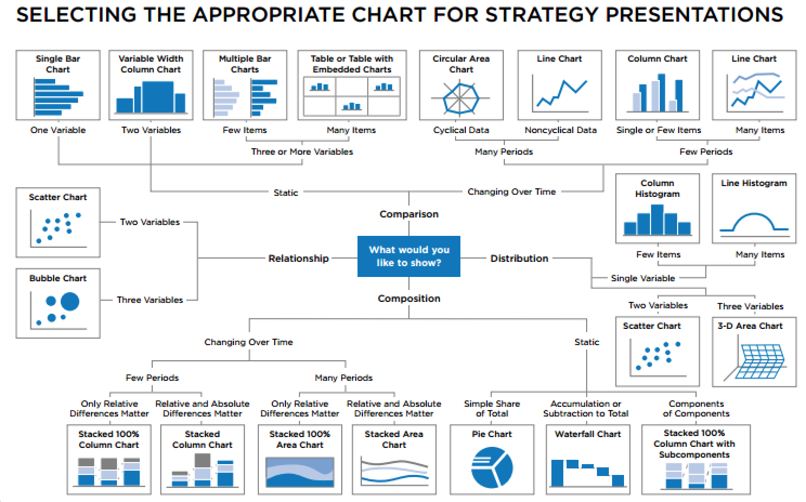

## A periodic table of visualization methods

Link: [Visual-literacy.org](http://www.visual-literacy.org/periodic_table/periodic_table.html)

Note: When hovering an element, a pop up window appears with explanation and image.

Note: Note interesting, not well done. Highly critized like [here](https://eagereyes.org/blog/2009/visualization-is-not-periodic-html).

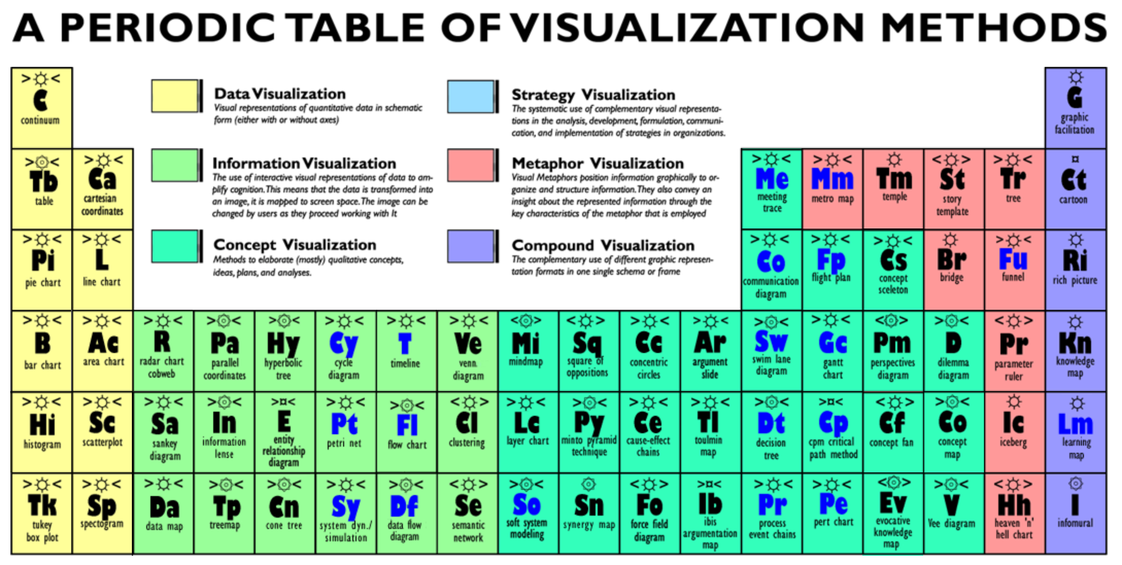

## A classification of chart types

Author :

Link : [Excelcharts.com](http://excelcharts.com/classification-chart-types/)

Description : Here is the idea: a chart can (a) help you compare data points faster but keeps each data point as the basic information unit or (b) help you generalize  the data and find patterns, making the data points less relevant. These roles should be as mutually exclusive as possible (but in real world that’s harder than expected).

There are six types of questions, three of them involving data comparison and the other three data reduction. The questions are:

* **Comparison:** comparing and sorting data points;
* **Composition:** part-to-whole comparisons;
* **Distribution:** comparison of data points along an axis;
* **Relationship:** relationship patterns between two or more variables;
* **Evolution:** time patterns;
* **Profiling:**  pattern comparison.

